

2 Minute Form
Trip Name: Manukau Harbour Bird Sanctuary and French Bay
Check-in Name and Phone:
Date: Branch: Auckland
Leaders
Cell Phone Number
VHF Call Sign &/or Vessel Name
Vehicle make, model, registration, colour
General Plan
Note: If plan changes, you must notify your Check-in person.
Latest Time Off the Water |  |  |  |  | TMP used²⁰
Tide/ Forecast | Low |  |  | High | Other
Communications Carried²¹
Communications | We will be communicating as a group on VHF Channel
Equipment Carried
Trip Report
(Use other side if more space required)

Activity | Club Paddle | Centre | Auckland | Location |  |  |  | Manukau Harbour |  | Difficulty¹ |  |  |  | Intermediate
Activity Description | Waikowhai to bird sanctuary, Puketutu Is. & French Bay |  |  |  | Leader qualification req.² |  |  | Leader
Get in Location | Waikowhai |  |  |  | Chart/ Map no.⁴ |  |  | NZ4314 |  | Distance |  |  |  | 21km
Get out Location | Waikowhai |  |  |  | Coastguard Channel |  |  | 81 & 16 |  | Nowcasting |  |  |  | 21
Emergency get out ⁵ | All beaches except at bird sanctuary at high tide, all coastline at low/mid tide. |  |  |  | Emergency / Coastguard Station |  |  | Auckland |  | Phone |  | *500 / 09 303 4303
Emergency get out ⁵ |  |  |  |  | Drinking Water⁶ |  | At beaches |  | Toilets⁷ |  |  |  | At Beaches
Emergency Response | Refer Emergency Response Booklet |  |  |  |  |  |  |  | Parking⁸ |  |  |  | Waikowhai
Specific Equipment Required⁹ | nil |  |  |  | Working Communications equipment in this area¹⁰ |  | Cell phone  Sat phone |  |  |  | Mountain Radio |  |  |  | PLB  VHF
Other resources  and notes¹¹ | Waikowhai is an all tide get-in with a rock base. At the very lowest tides there is a small amount of mud. |  |  |  | Weather Parameters¹² | Beginner: no significant surf or swell, wind under 15 knots.  Intermediate: surf or ocean swells less than 1.5 metres or wind under 25 knots.  Advanced: any condition that’s suitable for the trip’s aims.
Previous incidents¹³

Safety Management¹⁴
Hazard |  | Significant?  - E/I/M |  | Management Strategy¹⁵ |  |  |  | Hazard | Significant?  - E/I/M | Management Strategy¹⁵
Cold Water |  | Yes - M |  | Carry spare dry clothes and shelter |  |  |  | Deep Water | Yes - E | Correctly fit PFDs
Medical Conditions |  | Yes - M |  | - Leader has first aid qualification  - Ask customers about medical conditions |  |  |  | Bad Weather | Yes - M | Understand weather forecasts.  Have back up plans or pull out if necessary
Capsizing |  | Yes - M |  | - Correctly fit PFDs  - Skills at performing rescues. |  |  |  | Heat / Sun | Yes - M | - Protective Clothing (worn), Sunglasses, Hat  - Sun Screen  - Plenty of drinks
Panic |  | Yes - M |  | Ensure conditions match level  of skills |  |  |  | Obstacles | Yes - M | Awareness of reefs, navigational hazards, nets
Shipping channel |  | Yes - M |  | - Follow “rules of the sea”  - Be visible – brightly coloured kayaks, hats, flags etc.  - Cross channel as a tight group |  |  |  | Other Vessels | Yes - M | - Understand the “rules of the sea”  - “Be seen” – Have two of the following; flag, brightly coloured kayak, brightly coloured Pfd or hat. At night: an all- round white light & a powerful torch.
Tidal Flows |  | Yes - M |  | There are strong tidal flows in parts of the Manukau so be aware of this. Ensure that participants have the necessary skills. |  |  |  | Stranding | No | Between the bird sanctuary and Puketutu Is there is a significant amount of mud/sand banks exposed. Ensure that you get the tides right in this area or it is possible to get stranded if the tide is too low.  You have approx 2 hrs either side of high tides.
Written up by: | Denise Marsden |  | Approved By: |  | Russ Williams | Signed: | RW |  | Date: | 18 Nov 2014 | Review in: | 12 months from date of approval
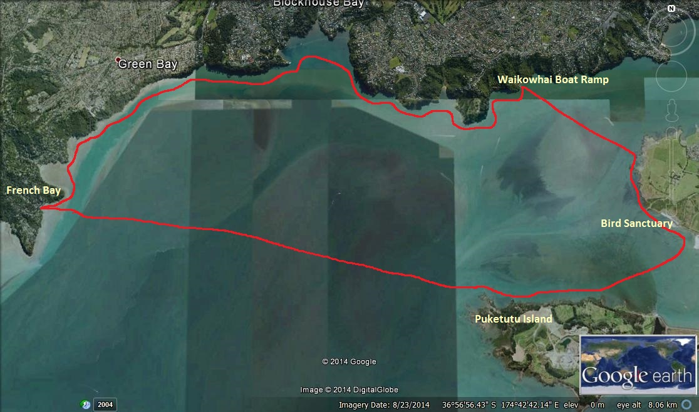

Additional Information Sheet (Optional)
Introduction (A general introduction) |  | An exploration of a great part of the Manukau Harbour
Description (A description of the tour – as if you were selling the idea to someone) |  | This is a great opportunity to explore part of the Manukau Harbour and discover a world-class bird sanctuary. The bird sanctuary, which is next to Ambury Regional Park, is home to over 80 species of birds, some of them endangered. You can expect to see thousands of birds including the impressive, white, royal spoonbills. From there we will head over towards Puketutu Island which is linked to the mainland by a causeway. The island is undergoing restoration after being quarried, but will one day become another of Auckland’s regional parks.
Local Attractions |  | Transport/ Local Operators
 | Contact details |  | Contact details
Local Eateries
 | Contact details
Accommodation/ Campsite Locations |  |  | Facilities
Name |  |  | Cabins |  | Fuel
Phone |  |  | Showers |  | Power
E-mail |  |  | Toilets |  | Water Access
Website |  |  | Laundry |  | Pool
Physical Address |  |  | Water |  | Fires Allowed
Other |  |  | Supplies
Other information

Activity Equipment Check list
Equipment List
- Helmet (rivers & surf) Group Gear
❑ Beanie / hat  Split paddles
❑ Thermals  Repair kit
❑ Paddle Jacket  Fire lighting
❑ PFD  Cooker/thermos
❑ Spray deck  Spare thermals
❑ Booties  Tow system
❑ Water & food  1st Aid Kit
❑ Kayak & paddle  Flares
Group - Oceans & Lakes  Compass
❑ Pumps & Paddle Floats  Charts / Maps
Group - River  GPS (optional)
❑ Throw ropes  Knife (cut rope)
❑ Pin kit & saw  Emergency Shelter

In case of emergency: Dial 111, Mayday :VHF Channel 16

Kayaking Check list

❑ Trip plan
❑ Latest weather forecast
❑ Conditions match skills?
❑ Hyperthermia (hot) &
Hypothermia (cold)
❑ On & off water safety
❑ Environmental concerns
❑ Emergency Procedures include emergency get out.
❑ Working communication devices
e.g. VHF radio, mobile phones, PLB
❑ Specific safety issues for this trip
❑ Participant list
❑ Any medical conditions
❑ All participants keen to proceed?

❑ Trip Plan/ 2-minute form lodged with Ops. Manager

Appropriate wind conditions to run trips:
Novice - no significant surf or swell, wind under 15knots
Intermediate- surf or ocean swells less than 1.5 metre or wind under 25 knots.
Advanced- any condition that is suitable to the trips aims

At conclusion of trip:
Contact check in person
Group Debrief.

Check in Person Ph:
__________________ Mobile
__________________ Work
__________________ Home

Activity Document Cover Sheet

Activity:
Date of Activity:

Activity reports. Is all relevant information present:
– Approved Trip Management Plan (TMP)/ 2 minute form
– Club Trip Participant Sheet
– Weather forecast
– Activity Check List
– Trip report (May be on the 2 minute form)
– Accident / incident reports
Leaders Signature:
Date:

